So in this course, we're going to be building a real-world, generative AI application. What this application will do is it will get a name and it will search for that name online. It will search LinkedIn, it will search Twitter.It will then get the information from those sources, and then we're going to be sending it to the Large Language Model, which is going to generate for us a summary, some interesting facts about that person,
Our second project is a documentation helper that digests the LangChain documentation, and now we're able to ask questions about the documentation, like how to implement certain things and also, it will point us to the origins of the documentation.
LangChain is a great platform to connect your agents to external sources like google, twitter, Wikipedia…

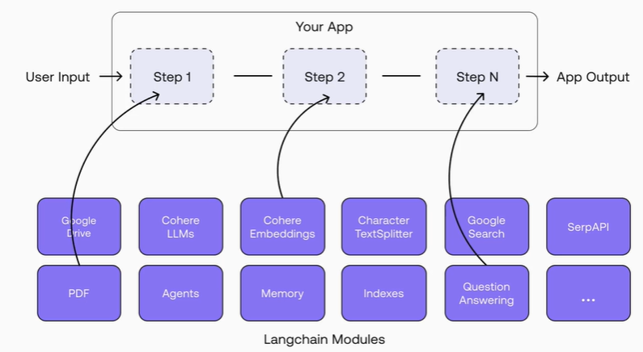

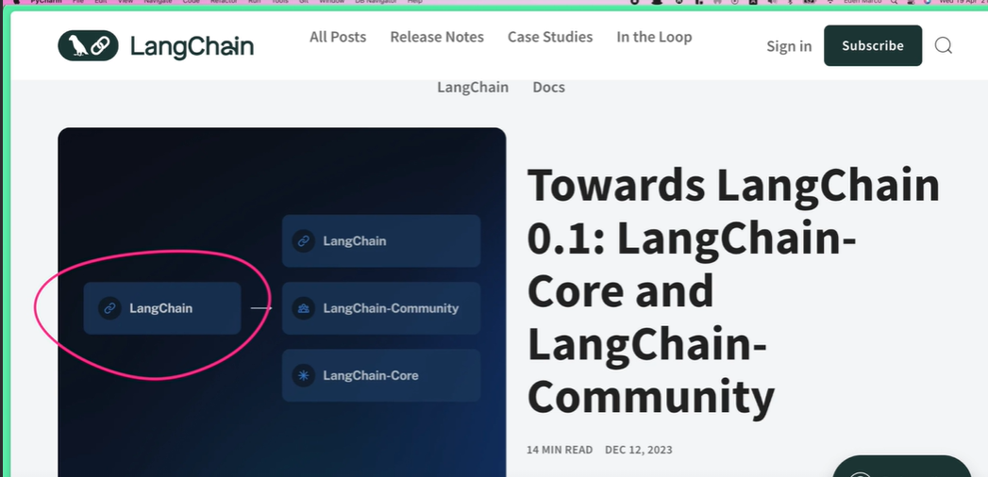

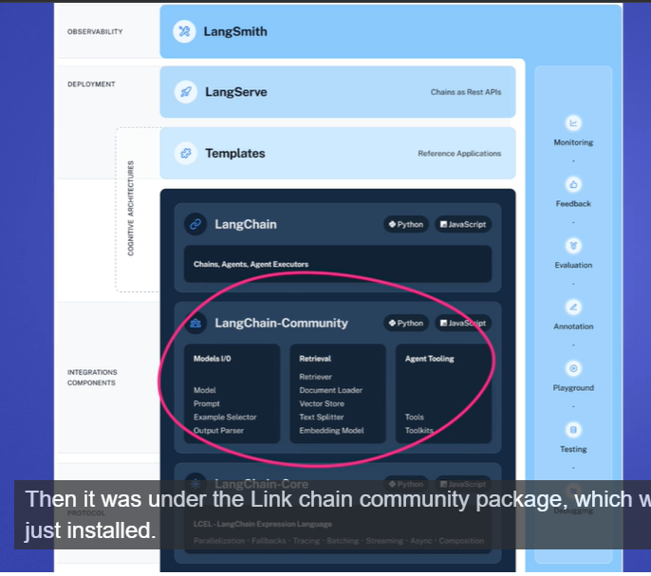
Each of the groups are separated
Install langchainhub, black
Regarding LLM’s for summaritzation and simpler tasks, many open source models are fine but for tasks that require more reasoning gpt4, sonnet 3.5 and gemini 1.5 are the best ones
To run ollama put in the terminal: ollama run llama3
Agents use LLM’s to perform tasks and comprehend what is required of them
After obtaining the text results of what the agents gather, it needs to be turned into a JSON. Ouput parsers do this.
Output parser is responsible for taking the output of a model and transforming it to a more suitable format for downstream tasks. Useful when you are using LLMs to generate structured data, or to normalize output from chat models and LLMs.
We wanna be able to trace LLM calls, tool usage, LLM model latency, token count and cost. LangSmith is a comprehensive developer platform designed to support the entire lifecycle of building and managing applications powered by large language models. Whether you’re using LangChain or not, LangSmith offers a range of tools and features to help developers debug, collaborate, test, and monitor their LLM applications12.
With Langsmith is really easy to understand what is the chain of thought and actions of the agents
Section 4 deep diving into the react framework

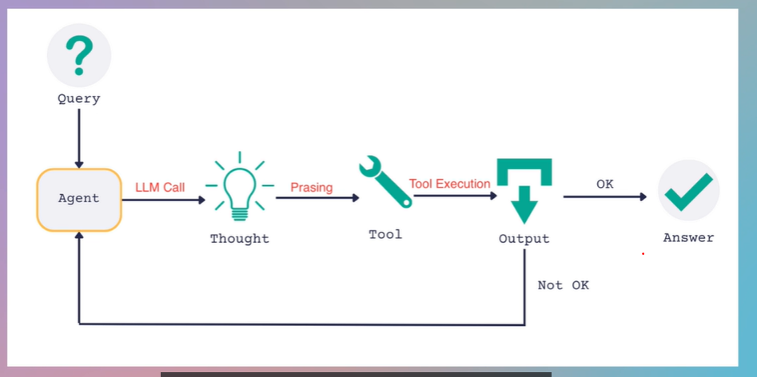
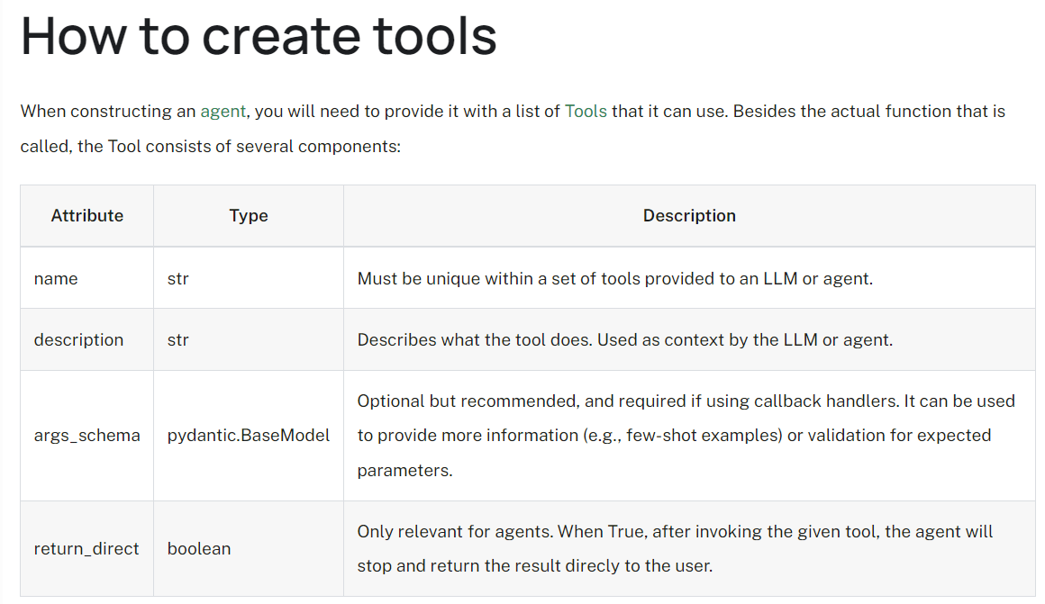
LangChain Expression Language (LCEL) is a declarative framework for composing and deploying chains, from simple to highly complex, without code changes. Key features include:
- First-class streaming support: Fast time-to-first-token and incremental output streaming.
- Async support: Usable with both synchronous and asynchronous APIs.
- Optimized parallel execution: Automatic parallel processing for reduced latency.
- Retries and fallbacks: Configurable for enhanced reliability.
- Access to intermediate results: Useful for debugging and user feedback.
- Input and output schemas: Automatic schema generation for validation.
- Seamless LangSmith tracing: Comprehensive logging for observability.
- Seamless LangServe deployment: Easy deployment of chains.
This makes LCEL a robust tool for both prototyping and production environments.
Section 5 - The GIST of RAG- Embeddings, Vector Databases and, & Retrieval
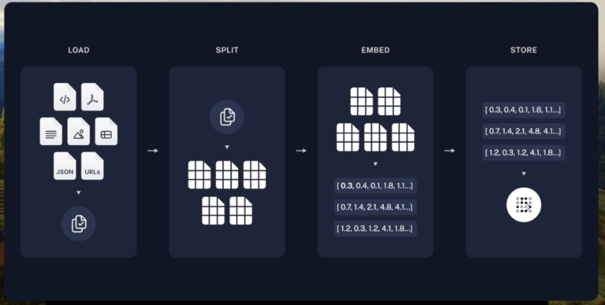
We will load the medium blog (TextLoader)
Splitting the blog into smaller chunks (TextSplitter)
Embed the chunks and get vectors (OpenAIEmbeddings)
Store the ebeddings in Pinecone vectorstore (PineconeVectorStore)
Langchain is great because we can use documents from whatsapp, pdf, google drive, and it has all implemented in it in the document loaders
A text splitter allows you to have a large text and splitting it into chunks
For chunking, if you use too many tokens it will be garbage, it is good to not make the chunk sizes too large
Retrieval implementation. We’ll use embedding user query, semantic search (relevant vectors), prompt augmentation and generation
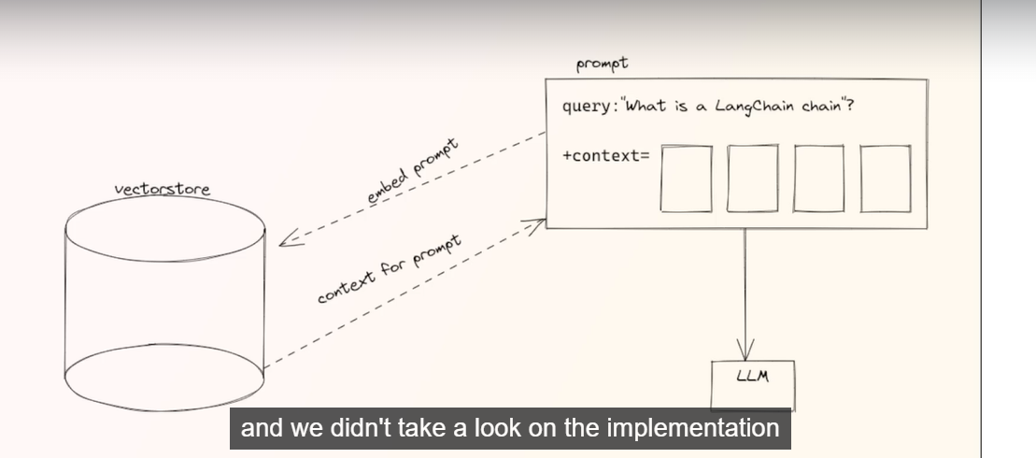

We will be using Local vector stores as well
Section 6: Building a documentation assistant (Embeddings, VectorDBs, Retrieval, Memory)
Documentation helper. Plugs in a certain document and query a LLM about it.
Cover Vector databases, RetrievalQA chain, Similarity search, LLM memory streamlit
We’ll download langchain documentation, chunk it, turn it into a vectorstore and use it. We’ll also introduce memory, as the chat will have past conversation
Streamlit is an open-source Python framework for data scientists and AI/ML engineers to deliver dynamic data apps with only a few lines of code. Build and deploy powerful data apps in minutes. Let's get started!
Section 7: Building a slim ChatGPT Code-Interpreter (Advanced Agents, OpenAI Functions)
Section 8 Langchain Theory
A problem with Agents is that they can execute code, so if they are ill intended it ca nbe a problem. Security and permissions is a priority when dealing with agents. This is a hackable point, where you train agents to do bad things
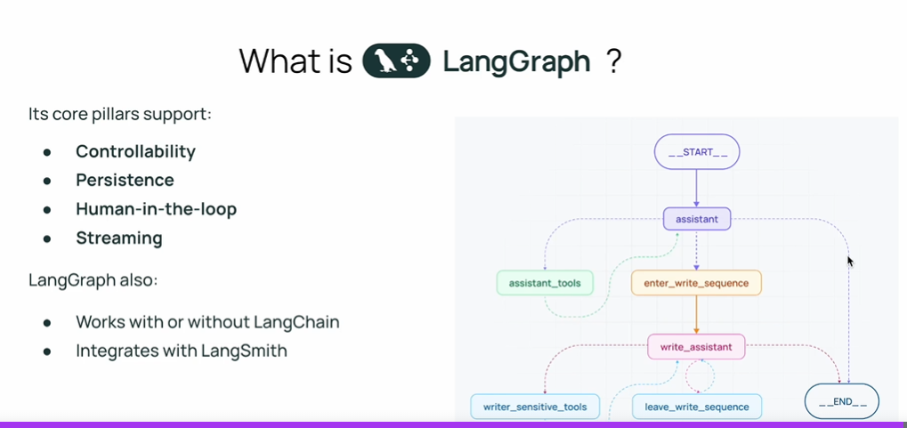
Personal notes
- Ollama is very slow, has a huge inference time. Supposedly (through others’ accounts of the same problem) mistral runs much faster than llama
- It’s interesting to see how these agents are not production-level ready at all, they are really unstable, sometimes they perform so so, sometimes they are just completely inadequate. Never, or really, rarely do they perform flawlessly. And two different runs lead to completely different results
- React is a combination of Chain of Thought and actions. Where the agents think about what they did, they reason it, and then act on it
- Agent is simply a control flow controlled by an LLM
- Text splitting playground is a good place to actually see the chunks of text

